Supplementary File for Safeer’s paper

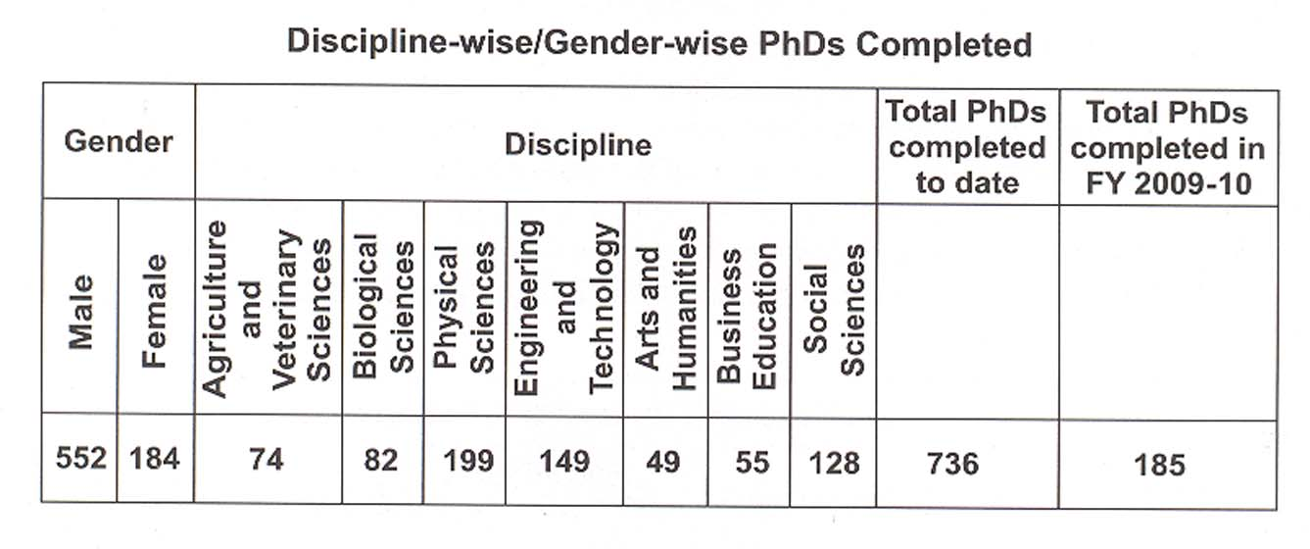

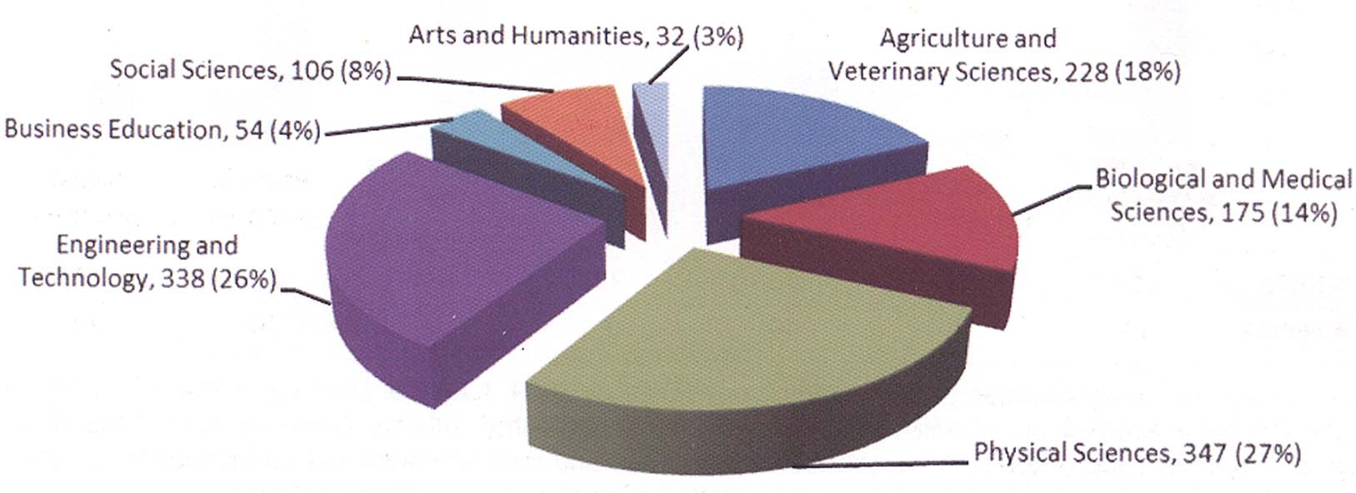

Diagram1

- MS/MPhil Leading to PhD Scholarship in Engineering, Natural and Basic Sciences, Humanities, Social Sciences for Teachers of Weaker Universities
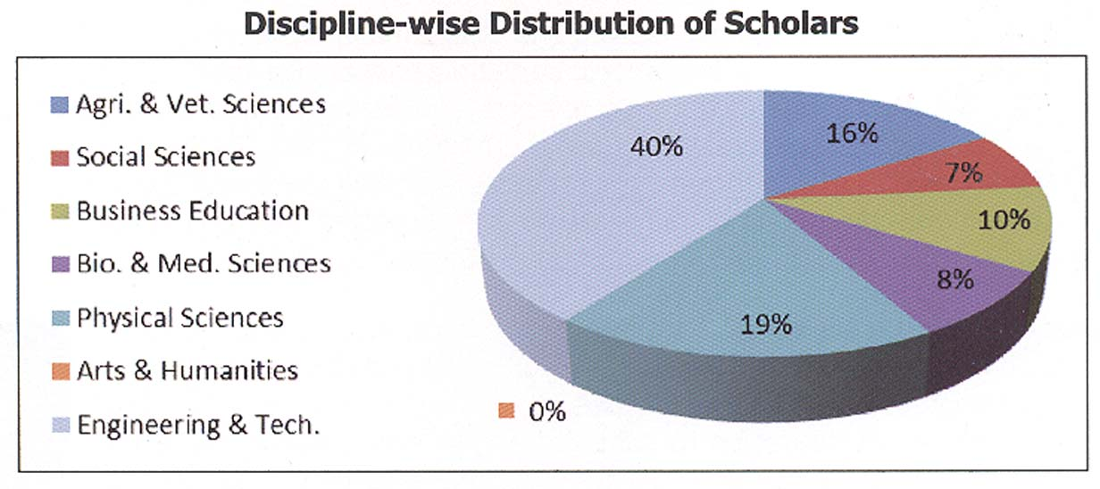

Diagram2

